Data Capturing Tool Usage Guide
This document will guide you through the process of using data capturing tools to collect data for UDTIP.
The workflow is shown in Figure 1.
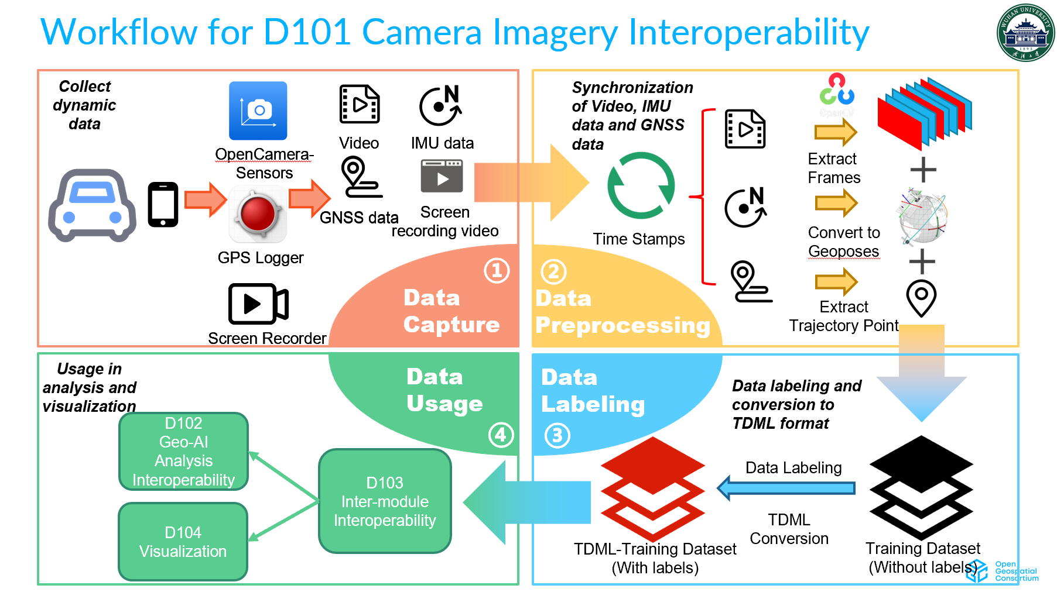
Figure 1. Workflow for D101.

Applications Installation
Before capturing data, there are two apps should be installed on your Android mobile phone.
The first one is the GPS Logger. It is used to capture GNSS data, and can be installed through Google Play. Make sure this app can run in the background.
The second app is OpenCamera-Sensors. It is an open-source app and the latest apk can be downloaded from GitHub releases.
For both of the apps, the appropriate permissions should be granted.

Application Settings
For OpenCamera-Sensors, accelerpmeter, gyroscope and magnetometer should be enabled and the video resolution should be set to Full HD (1920×1080).

Data Capturing
- Start recording GNSS Data with GPS Logger.
- Use the screen recording function that comes with your phone to record your screen. It need to be set to 30 fps before recording.
- Start recording video and IMU data using the OpenCamera-Sensors.
- Show a clock in front of the camera and stay at least five seconds. This will help align the timestamps during data preprocessing.
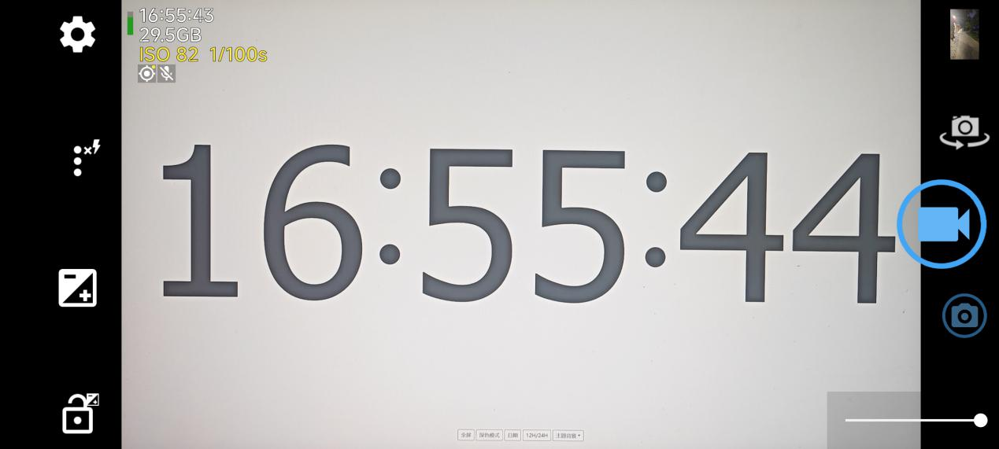
Figure 2. Screen record.

Data Export
- GPS Logger: You can check the recorded trajectories in the trajectory list. And it can be exported in kml and gpx format.
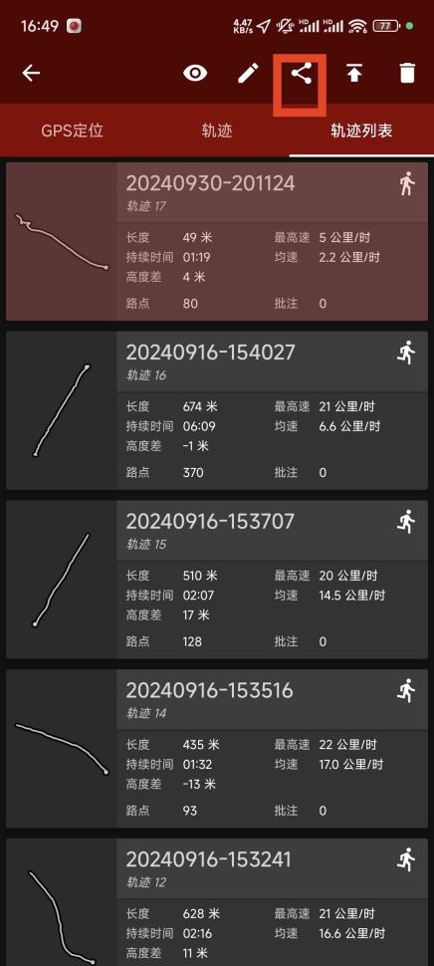
Figure 3. Upload the GNSS log.
- Screen Record: The screen recorded video needs to be exported.
- OpenCamera-Sensors: Connect the phone to the PC and export the data from the phone. Get data from “DCIM/OpenCamera”.
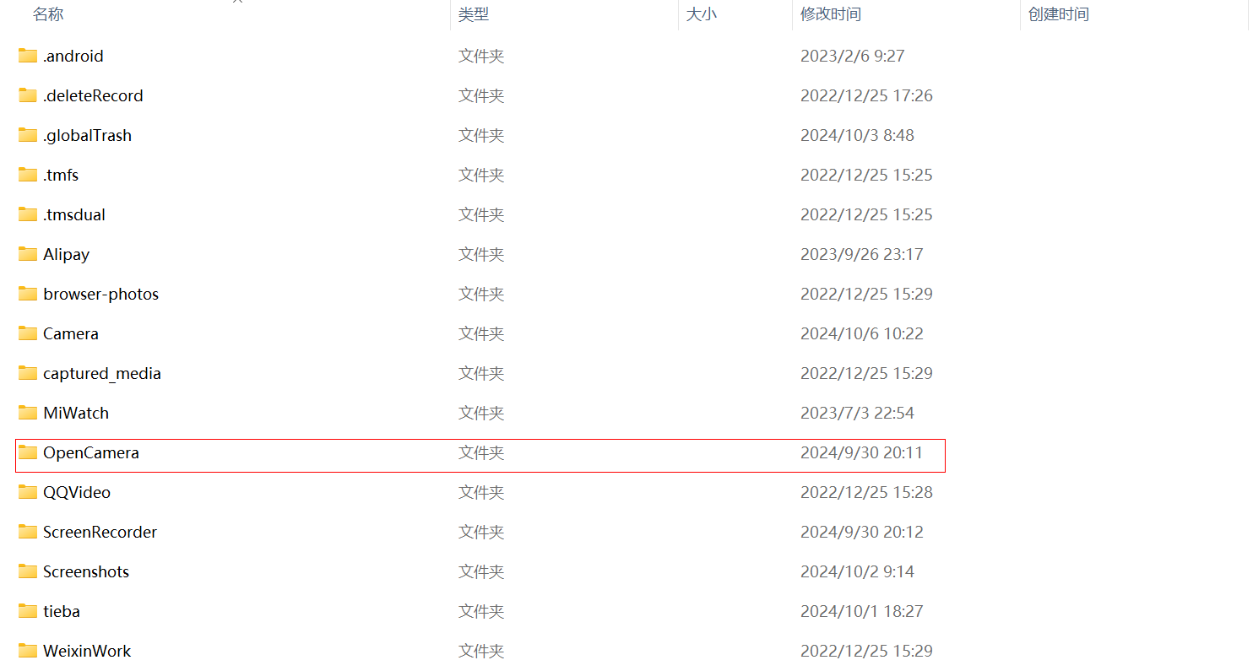
Figure4. The dictionary of data captured.
And in this dictionary, export both the video and IMU data.
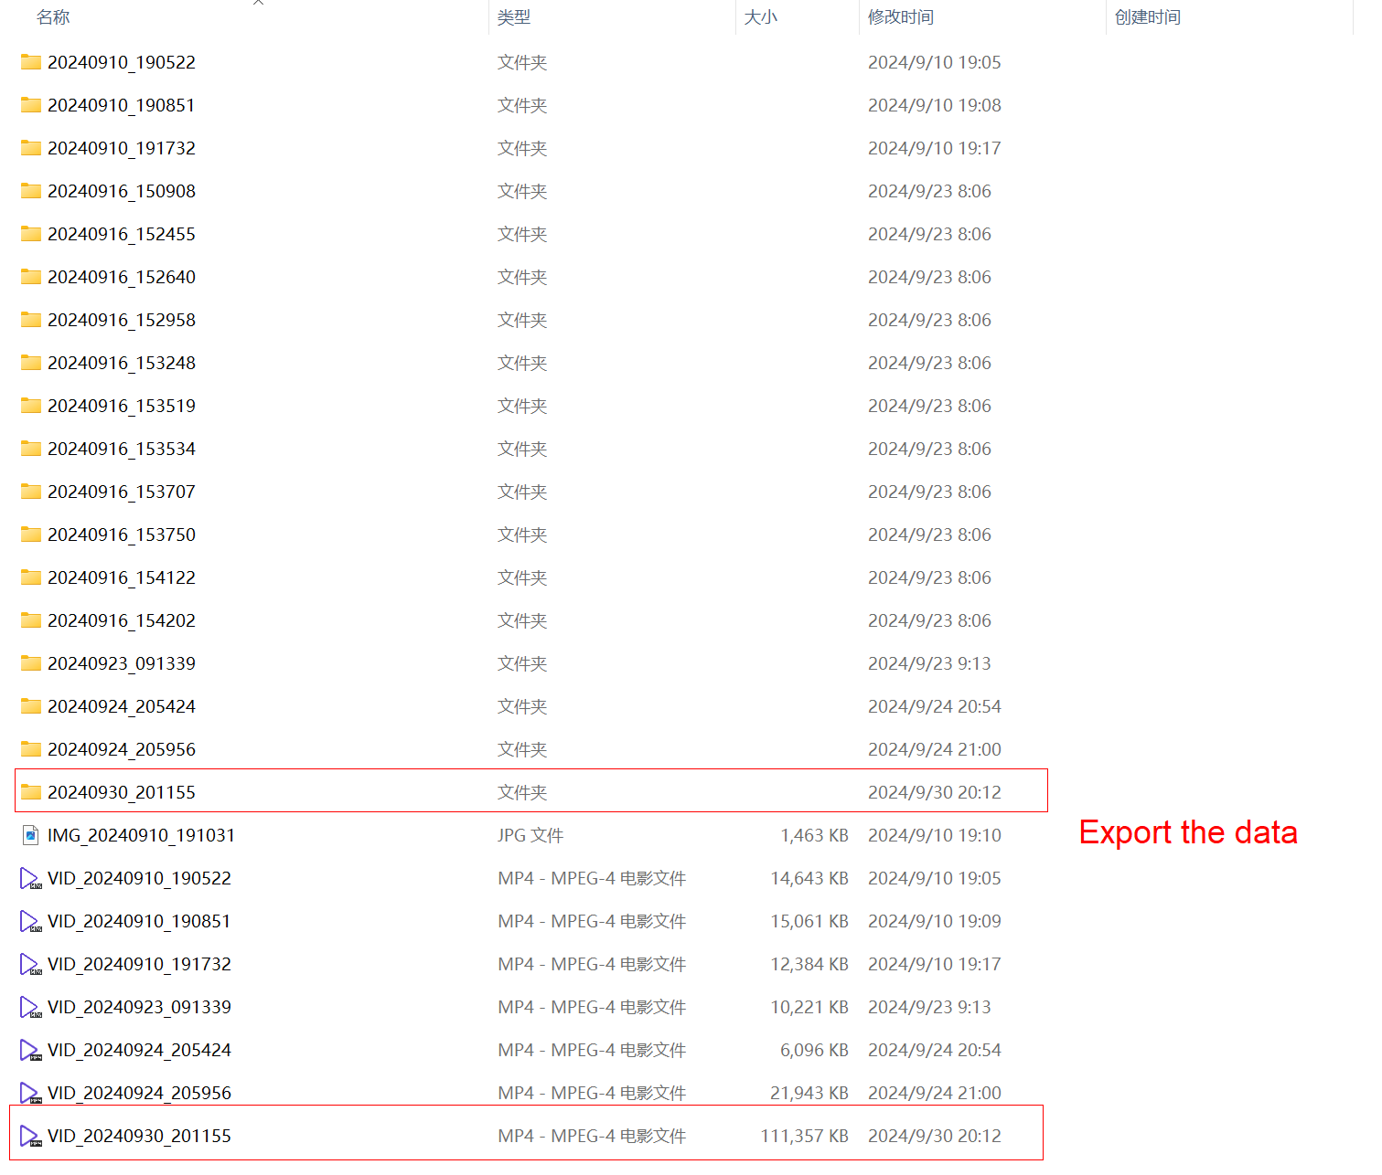
Figure 5. Export the data.

